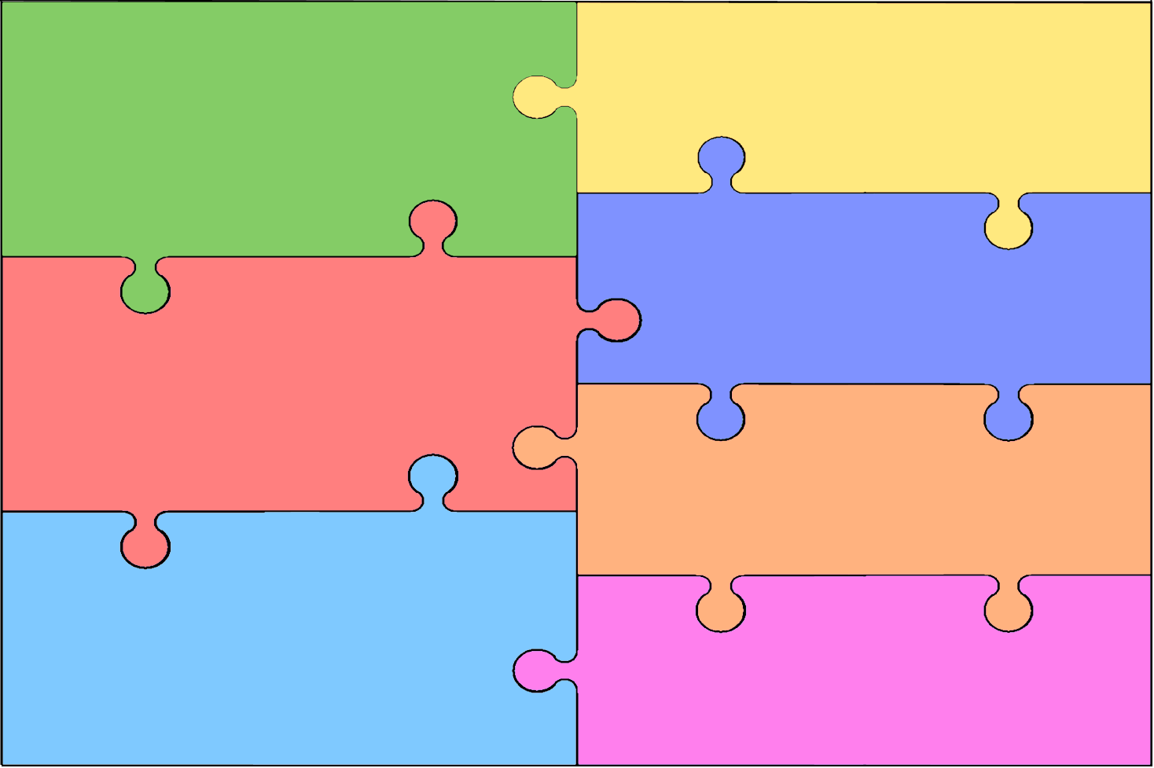
Curriculum Overview for Music-Charanga.
Year six  - Happy-Being happy.  - Classroom Jazz 2- Jazz improvisation and composition.  - A New Year Carol-Benjamin Britten’s music and cover versions.  - You’ve got a friend-The music of Carole King.  - Music and Me-Create your own music inspired by your own identity and women in the music industry.  - Reflect, rewind and replay-History of music-look back and consolidate your learning. Learn some of the language of music. | EYFS  - Me – Clap the rhythm. Explore high/low sounds using voices and glockenspiels.  - My Stories- Find the pulse in a song. Clap the rhythm of small phrases. Explore high/Low pitch. Invent a pattern to go with a song.  - Everyone-Invent ways to find the pulse. Clap some rhythms of phrases from songs. Explore high/low pitch. Explore melodic patterns.  - Our World-Find the pulse and show others your ideas. Clap some rhythms of phrases. Explore high/low pitch. Explore melodic patterns.  - Big bear funk- Find a funky pulse. Clap 3 or 4 word phrases. Keep the beat of the song. Add pitched notes to the rhythm of the words. Enjoy playing patterns with notes.  - Consolidate learning and contextualise the history of music.
Year one
- Hey You- How pulse, rhythm and pitch work together.
- Rhythm in the way we walk and the banana rap- Pulse rhythm and pitch. Rapping, dancing and singing.
- In the groove- How to be in the groove with different styles of music.
- Round and round-Pulse, rhythm and pitch in different styles of music.
- Using your imagination-
- Reflect, rewind and replay-History of music-look back and consolidate your learning. Learn some of the language of music.
Year five

- Livin on a prayer-Rock Anthems
- Classroom Jazz 1- Jazz and improvisation
- Make you feel my love-pop ballads
- The Fresh Prince of Bel Air-Old school hip hop.
- Dancing in the street-Mowtown
- Reflect, rewind and replay-History of music-look back and consolidate your learning. Learn some of the language of music.
Year two

- Hands, feet, heart- South African music.
- Ho, Ho Ho! Festivals and Christmas.
- I wanna play in a band- Playing together in a band.
- Zoo time- reggae and animals
- Friendship song- A song about being friends.
- Reflect, rewind and replay-History of music-look back and consolidate your learning. Learn some of the language of music.
Year four

- Mamma Mia- Abba’s music.
- Glockenspiel 2-exploring and developing playing skills using the glockenspiel
- STOP! – writing lyrics linked to a theme.
- Lean on me-Soul Gospel music and helping one another.
- Blackbird-Beatles- Equality and civil rights.
- Reflect, rewind and replay-History of music-look back and consolidate your learning. Learn some of the language of music.
Year three

- Let your spirit fly-RNB and other styles.
- Glockenspiels stage 1-exploring and developing playing skills.
- Three little birds- Reggae and animals.
- The dragon song- Music from around the world-celebrating our difference and being kind to one another.
- Bringing us together-Disco friendship, hope and unity.
- Reflect, rewind and replay-History of music-look back and consolidate your learning. Learn some of the language of music.

