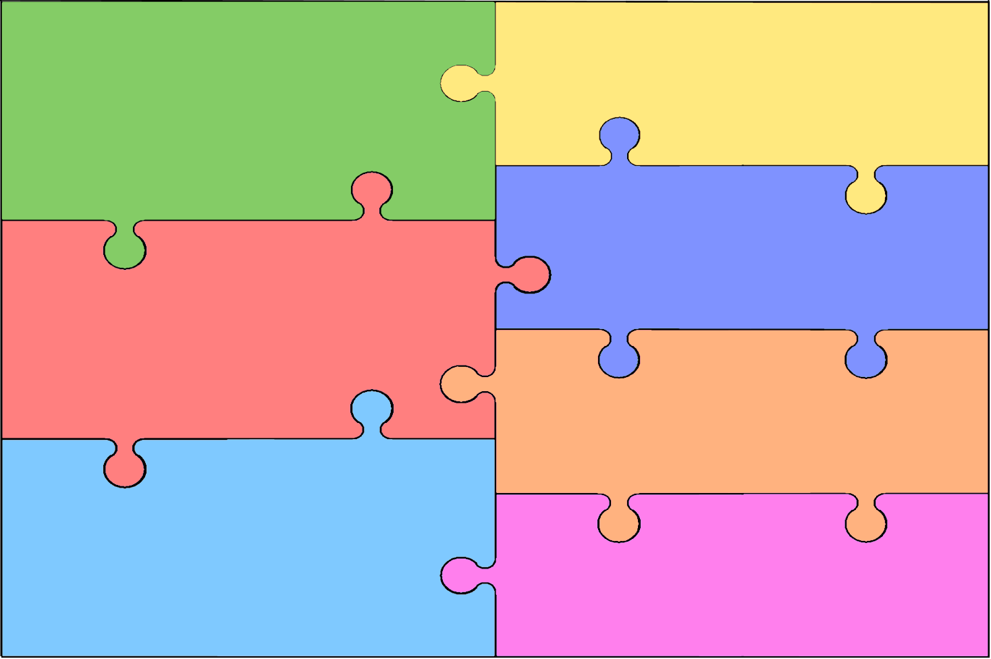
Curriculum Overview for Maths
Year six  - Place Value – compare and order to ten million, round, negative numbers  - Addition and Subtraction – multi step problems, estimate, negatives  - Multiplication and Division – formal, long multiplication and division  - Fractions – four rules, compare, number lines, simplify, mixed numbers  - Decimals– multiply and divide, place value, order, thousandths  - Percentages – percentage of an amount, equivalent to fractions, decimals  - Algebra – rules, substitutions, formulae, equations, pairs of values  - Statistics – line graphs, circles, pie charts, mean  - Shape and Measure - converting units, parallelograms, triangles, volume | EYFS  - Have a deeper understanding of numbers to 10, including the composition of each number.  - Recognise numbers without counting up to 5 (subitising)  - Explore and represent patterns with numbers up to 10.  - Automatically recall number bonds up to 5, including subtraction facts and some number bonds.  - Compare quantities up to 10 in different contexts.  - Recognise and name some 2D and 3D shapes.  - Have some understanding and awareness of time, length, capacity and mass.
Year one
- Place Value – Number within 100
- Addition and Subtraction – to 20
- Multiplication and Division – 2s, 5s, 10s, groups and arrays
- Measurement – Compare height and length, introduction to cm
- Measurement – Compare weight and volume, non-standard units
- Geometry – recognise 2D and 3D shapes, make patterns
- Geometry – position and direction, describe movements
Year five

- Place Value – numbers to 100,000, Roman Numerals, negatives, rounding
- Addition and Subtraction – multi step problems, estimating, inverse
- Multiplication and Division – multiples, primes, factors, 10,100,1000
- Fractions – add, subtract, multiply, fractions of quantities, mixed numbers
- Decimals and Percentages – 2 DP, decimals as fractions, percentages
- Statistics – line graphs, tables, 2 way tables, timetables, problems
- Perimeter and area – calculate, rectilinear and compound shapes
- Geometry – angles, protractors, regular and irregular polygons
- Measurements and shape – converting units, volume

Year two

- Place Value – counting in 2s. 5s, 10s, 3s; count objects to 100.
- Addition and Subtraction – crossing ten, bonds to 100
- Multiplication and Division – 2s, 5s, 10s, tables, groups and arrays
- Money – find total and difference, count amounts of money
- Statistics – tallies, pictograms, block diagrams
- Fractions – half, quarter, third Length and Height – cm, metres – compare, order
- Geometry – properties of shape, describe position and turn
Year three

- Place Value – Compare and order numbers to 1000, use number lines
- Addition and Subtraction – use 3 digit numbers crossing 10 and exchange
- Muptiplication and Division – 2,4,8,times; times 2 digits by 1 digit, formal methods
- Money – pounds and pence, add and subtract, problem solving
- Statistics – tallies, pictograms, bar charts – 2s, 5s, 10s
- Fractions – equivalents; plus time, length, mass, capacity – units, problem solving

Year four
- Place Value – number lines, rounding, partitioning up to 10,000
- Addition and Subtraction – up to10,000 with exchange; estimating
- Multiplication and Division – divide by 10 and 100, all tables, formal
- Decimals – round, order, write, compare, halves and quarters
- Money – problems, change, convert units,
- Time – 24hr, 5 minute intervals, analogue to digital and vice versa
- Fractions – unit and non, adding, fractions greater than 1, tenths
- Statistics – charts, line graphs, comparison, sum, difference
- Measure – area (non-standard), Shape – lines and angles

