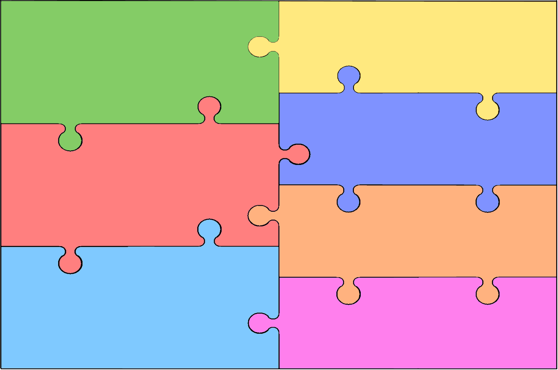
Curriculum Overview for Early Years Foundation Stage
Personal, Social & Emotional Development  - Show to understand their own feelings and those of others.  - To be able regulate their behaviour when appropriate.  - Wait for what they want, work towards simple goals, and control impulsive behaviour.  - Give focused attention.  - Be confident to try new activities and show independence.  - Show resilience and perseverance, when challenged.  - Explain right from wrong and refer to rules.  - Manage their own basic hygiene and personal needs.  - Work and play co-operatively and take turns.  - Form positive relationships with adults and children.  - Show sensitivity. | Literacy  - Use phonics to decode straightforward words  - Read simple sentences and books that are consistent with their phonic knowledge.  - Discuss what has been read  - Use phonics knowledge to write simple words and sentences, including labels.  - Write recognisable letters, mostly formed correctly.  - Spell words by identifying sounds in them and representing the sounds with a letter or letters.
Mathematics

- Have a deeper understanding of numbers to 10, including the composition of each number.
- Recognise numbers without counting up to 5 (subitising)
- Explore and represent patterns with numbers up to 10.
- Automatically recall number bonds up to 5, including subtraction facts and some number bonds.
- Compare quantities up to 10 in different contexts.
- Recognise and name some 2D and 3D shapes.
- Have some understanding and awareness of time, length, capacity and mass.
Communication & Language

- Listen attentively and respond to what they hear.
- Make comments on what they have heard or have been asked.
- Hold a conversation with other children and adults.
- Show the ability to participate in discussions.
- Offer explanations to why things might happen.
- Express their ideas and feelings, with meaning and correct tenses, with some support from modelling from an adult.

Understanding the World
- Talk about the people around them.
- Know some similarities and differences between things in the past and now.
- Describe their immediate environment
- Know some similarities and differences between different religious and cultural communities in this country.
- Explore the natural world around them
- Understand some important processes and changes in the natural world around them.
Physical Development

- Negotiate spaces and obstacles safely.
- Show strength and balance and co -ordination.
- Show the ability to run, skip, jump, hop and climb.
- Hold a pencil effectively, ready for fluent writing.
- Use scissors, paintbrushes and cutlery.
- Show accuracy when drawing.
Expressive Arts & Design

- Safely use a variety of materials, tools and techniques.
- Experiment with colour, design, texture, form and function.
- Share creations and talk about them.
- Use props and materials to act out role play and stories.
- Perform songs, rhymes and poems and stories with others.
- Move to music.

