Special Educational Needs and Disabilities
(SEND) Information Report
2023 (reviewed and updated March 2023)

St Joseph’s is an Academy and part of the ‘Our Lady of Lourdes Catholic Multi-Academy Trust’. We deliver an educational journey from the age of 3 to 11 that promotes each child’s development, both academically and pastorally, to ensure confidence and ambition. We are fully inclusive and believe that every child, regardless of any Special Educational Needs and/or Disabilities (SEND), should be given the opportunity to reach their full potential and be supported to access the whole of the curriculum on offer, in accordance with the 2014 SEND Code of Practice. Our philosophy is that education should provide each and every pupil with the core skills needed to achieve academic excellence through a diverse and rich programme of study that has holistic development at its core. We ensure that our Admissions Policy does not discriminate against children who have been identified with a Special Educational Need or Disability.

Definition
The SEND Code of Practice (1.xiii-xiv) defines SEND as, ‘A child or young person has SEN if they have a learning difficulty or disability which calls for special educational provision to be made for him or her. A child of compulsory school age or a young person has a learning difficulty or disability if he or she:
• has a significantly greater difficulty in learning than the majority of others of the same age, or
• has a disability which prevents or hinders him or her from making use of facilities of a kind generally provided for others of the same age in mainstream schools or mainstream post-16 institutions.’

St. Joseph’s Catholic Primary School recognises and values the principles outlined in the SEND Code of Practice. The following principles are observed by all staff and professionals working with our children who have SEND or disabilities:

- We take into account the view of children and their families;
- We enable children and their parents to participate in decision-making;
- We collaborate with partners in education, health and social care to provide support;
- We identify the precise needs of children;
- We make high quality provision to meet the needs of children;
- We help children to prepare for secondary education.

Legislation and Guidance
This Information Report is based on the statutory Special Educational Needs and Disability (SEND) Code of Practice and the following legislation: Part 3 of the Children and Families Act 2014, which sets out schools’ responsibilities for pupils with SEN and disabilities The Special Educational Needs and Disability Regulations 2014, which set out schools’ responsibilities for education, health and care (EHC) plans, SEN co-ordinators (SENCOs) and the SEN information report. In North East Lincolnshire, this forms part of a Local Offer (LO) and details about our SEND provision, and that of other schools and agency provisions, will be found under a dedicated Local Offer website found here.

What are the kinds of SEND that are provided for at St Joseph’s?
The Code of Practice refers to four broad areas in which your child’s needs may fall. However, these are not definitive categories in which to ‘place’ children. These areas are:

• Cognition and Learning needs, for example, dyslexia, dyspraxia, dyscalculia
• Communication and Interaction needs, for example, Autistic Spectrum Condition and speech and language differences
• Sensory and Physical needs, for example, hearing difficulties and sensory processing differences
• Social, Emotional and Mental Health needs, for example, attention deficit hyperactivity disorder (ADHD)

Currently at St Joseph’s 27.5% (20.3% SEN support, 7.2% EHCP) of the school population are classed as having ‘Special Educational Needs’.

The SENCO is Mrs Claire McHugh (office@sjp.academy, 01472 690672).

Training of staff

Our SENCo is currently completing the NASENCO qualification (due to complete April 2023).

Our school is part of the ‘Autism in Schools’ project. Mrs McHugh is our champion on the project with Miss Westfield as deputy champion and has completed vatrious training through this project, including; Making Sense of Autism, Autism in Girls.

We are a trauma informed school and have ‘Therepeutic School Status’. All staff have accessed training through TPC Therapy.

We have staff in school, trained in; intensive interaction, Beat Dyslexia, precision teaching, Nuffield Early Langauge Intervention (NELI)

How do we identify pupils with SEN and assess their needs?
At St. Joseph’s Catholic Primary School, we place great importance on identifying special educational needs and disabilities early so that we can help children as quickly as possible.

We identify pupils and assess their needs by;
• Listening to your views and concerns
• Listening to your child’s views and concerns
•Feedback from staff
• Making regular assessments of children
•Information from previous settings
• SENCO observations
•Rigourous data assessment
• Reviewing intervention impact
• Monitoring children’s emotional, social and mental-health well-being
• Information from external agencies, for example Paediatricians and the Speech and Language Service
• Monitoring pupils’ progress in comparison to peers locally and nationally

Where a child is making less progress than expected, the first response to such progress is high quality teaching that is targeted at areas of weakness. However, if pupils continue to make less than expected progress, despite this high quality teaching intervention, the teacher, working with the SENCo, will assess whether the child has SEND. The pupil’s response to such support helps to identify their particular needs. We follow a ‘graduated approach’.

The Graduated Approach recognises that children learn in different ways and can have different levels of SEND. Therefore, increasingly, step-by-step, specialist expertise may be brought in to help school with the difficulties that a child may have. Parents are fully informed in the event of the involvement of specialists. This extra or different help could be a different way of teaching certain things, some extra help from an adult, either one-to-one or in a small group, or use of particular equipment like a computer or other physical resource. Please note that help may be needed through the graduated approach for only a short time or for many years, perhaps even for the whole of your child’s education. School staff use our SEND identification flow chart to make this process very clear.

Persistent disruptive or withdrawn behaviours do not necessarily mean that a child or young person has SEND. Where there are concerns, there will be an assessment to determine whether there are any causal factors, such as undiagnosed learning difficulties, difficulties with communication or mental health issues. If it is thought housing, family or other domestic circumstances may be contributing to the presenting behaviour, a multi-agency approach, supported by the use of approaches such as Early Help Assessment, may be appropriate.

Staff are alert to other events that can lead to learning difficulties or wider mental health difficulties, such as bereavement. Such events will not always lead to children having SEND but it can have an impact on well-being. We ensure appropriate provision is made in order to prevent problems escalating. Where there are long-lasting difficulties, we would consider whether the child might have SEND.

Slow progress and low attainment do not necessarily mean that a child has SEND and should not automatically lead to a pupil being recorded as having SEND. However, there may be an indicator of a range of learning difficulty or disability. For example, some children and young people may be high achieving academically, but may require additional support in communicating and interacting socially. Some learning difficulties and disabilities occur across the range of cognitive ability and, left unaddressed may lead to frustration, which may manifest itself as disaffection, emotional or behavioural difficulties.

Identifying and assessing SEND for children or young people whose first language is not English requires particular care. We look carefully at all aspects of a child or young person’s performance in different areas of learning and development or subjects to establish whether lack of progress is due to limitations in their command of English or if it arises from SEND or a disability. Difficulties related solely to limitations in English as an additional language are not SEND.

Where a pupil continues to make less than expected progress, despite evidence-based support and interventions that are matched to the pupil’s areas of need, we will consider involving specialists. This could include, for example, a speech and language therapist, specialist teachers for the hearing or visually impaired, occupational therapists or physiotherapists. Parents will always be involved in any decision to involve specialists. The involvement of specialists and what was discussed or agreed is recorded and shared with parents and teaching staff supporting the child in the same way as other SEND support.

As a school we buy into the following services to ensure specialist expertise is available to support your child:

Specialist Advisory Service
Applied Psychologies

We can also make referrals to other agencies, as needed, including; Compass Go, SALT, School nursing, YMM, EBBSA and Early Help.

What is the Local Offer?

The Children and Families Bill became enacted in 2014. Since this date, Local Authorities and schools have been required to publish and keep under review information about services they expect to be available for children and young people with Special Educational Needs (SEN) aged 0-25. This is the ‘Local Offer’.

The intention of the Local Offer is to improve choice and transparency for families. It will also be an important resource for parents in understanding the range of services and provision in the local area. North East Lincolnshire’s Local Offer can be found here.

What should you do if you are concerned your child may have a special educational need?
If you are concerned that your child may have a special educational need (SEN) then we recommend that you first speak to your child’s class teacher. Class teachers are usually available at the end of the school day or an appointment can be arranged via the school office (690672). They will then action the SEND identification procedure. The SENCo is also available if you want to discuss your child’s needs further. The SENCo is available on Tuesday morning, all day Wednesdays and Thursdays via telephone (690672) or class charts. Class charts is checked between the hours of 8.30am and 3.30pm on these days. If you have an urgent query it is always best to contact the school office who will arrange for you to be contacted.

If you want to talk to someone who is independent and knows about Special Educational Needs, you can get advice from SENDIASS. Contact details can be found here.

How do we consult with parents?
We strongly believe that a child’s education is a partnership between parents and teachers. As a result, we aim to communicate regularly with you. You are invited to discuss your child’s progress at parents’ evening, where reviewed and new Personal Learning Plans (PLPs) will be shared. On the PLP, your child will have individual targets which will be discussed with parents on a regular basis. The targets are SMART (Specific, Measurable, Achievable, Realistic, Time-Scaled) with the expectation that a child will achieve the target by the time it is reviewed. PLPs are shared three times a year (February, May and October). The class teacher will offer advice and practical ways that you can help your child at home.

When appropriate, if outside agencies are involved with your child, you will be invited in or offered a telephone appointment with them. Recommendations from external agencies will be shared with you so that strategies can be implemented at home and school.

If your child has a complex special educational need or a disability they may have an Education and Health Care Plan (EHC Plan), which means that a formal meeting will take place annually to review your child’s progress.

Please feel free to contact school and make an appointment at any time to meet with either the class teacher or Mrs McHugh where you will be able to discuss how your child is progressing.

How do we consult with young people?
After each ‘Personal Learning Plan’ (PLP) cycle (Feb, May and October) the children with SEND help to review their plans, focusing on whether they have met their targets and setting new targets. Adjustments are made, where needed, to capture their voice. All children with SEND create a pupil passport which ensures all staff are aware of their needs, including:

- What I enjoy doing/am confident with
- What people like about me
- What makes me happy
- What do I find difficult
- What adults help me
- How do I want to be helped
- What makes me angry/upset
- My safe place in school

Children with an EHCP contribute to their plans before each annual review. Where appropriate, they attend the first stage of the review.

How do we assess and review progress?
Class teachers, supported by the Senior Leadership Team, make regular assessments of progress for all pupils. Where possible, pupils with SEND will be assessed in line with school practise and policy. In the first instance pupils not working at age related expectations in the core subjects for their year or term will be assessed using the appropriate year e.g. a year 4 pupil who is currently working at year 2 will have this reflected in their assessment data. Alternative assessment to track progress in the core subjects will be considered when a pupil, with or without SEND, is not making progress and has shown static progress over a period of time and is below age related expectations. In this instance we use the small steps and pre key stage documents provided by the Local Authority.

We also assess progress in areas other than attainment. For instance, where a child needs to make additional progress with wider development or social needs in order to make a successful transition to Secondary School, then we would put in place extra interventions and support to meet these needs.
We also measure progress against PLP targets. Teacher observation, views of the pupils and parents all feed into this assessment. For children with more complex Social, Emotional and Mental Health (SEMH) we use the SPOT tool to measure progress.
Outside agencies will sometime recommend specific assessment tools, such as:
- AET ASD progression framework

How do we support pupils moving between phases and preparing for adulthood?
• Before children move into their new classes in September, they have the opportunity to meet their new teachers and to experience some time in the new class.
• Transition between Nursery and FS2 will be the same, regardless of whether they have come from our nursery or if they have come from another nursery provision. All children will have a transition day which is a taster day in meeting their class teacher for the following academic year
• For vulnerable or students with more complex needs, the school offers an additional enhanced transition day where students meet the pastoral and SEND support team, ensuring that they feel comfortable with extra support.
• Transitioning to new schools in the academic year – if your child is moving to or from a new school within the school year then we will share information with the school or other setting the pupil is moving to.
• When transitioning to secondary school, the school SENCo will meet with the secondary SENCo and will pass over information linked to a child’s SEN needs ensuring the new school know best how to support the child’s needs. Paperwork will also be transferred across via a secure server. For children with an EHCP, parents will be asked which secondary school they are considering for their child and the SENCo will be invited to the annual review which will be held early (ideally in September of Year 6). Wherever possible additional transition days will be offered.

What is our approach to teaching pupils with SEN?
At St Joseph’s, we are proud to be inclusive and will endeavour to support every child regardless of their level of need. All pupils follow the National Curriculum at a level and a pace that is appropriate to their abilities. We have five particular approaches, informed by EEF research which supports our teaching of all children including those with SEN.
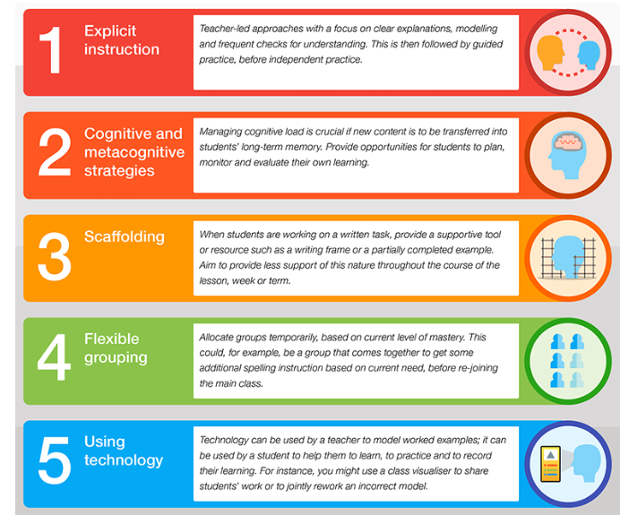

Quality first teaching is our first step in responding to pupils who have SEN. This will be differentiated for individual pupils. This forms part of the ‘graduated approach’. The Graduated Approach recognises that children learn in different ways and can have different levels of SEND. Therefore, increasingly, step-by-step, specialist expertise may be brought in to help the school with the difficulties that a child may have. Parents are fully informed in the event of the involvement of specialists. This extra or different help could be a different way of teaching certain things, some extra help from an adult, either one-to-one or in a small group, or use of particular equipment like a computer or other physical resource. Please note that help may be needed through the graduated approach for only a short time or for many years, perhaps even for the whole of your child’s education.

In our classes, we have a number of Teaching Assistants (TAs) who support pupils across the classes. The TAs support in class and with interventions. Reasonable adjustments are made in response to need. This is in all subjects including the foundation subjects, where subject leaders have thought carefully about what is in place in each subject to support children with SEND.

Pupil passports and personal learning plans ensure staff are aware and sensitive to the needs of all pupils. At times and when it is felt appropriate, modifications to the curriculum may be implemented. Some children may have a personalised timetable tailored to their specific needs.

Alongside this, for those children that need it we offer specialist interventions.

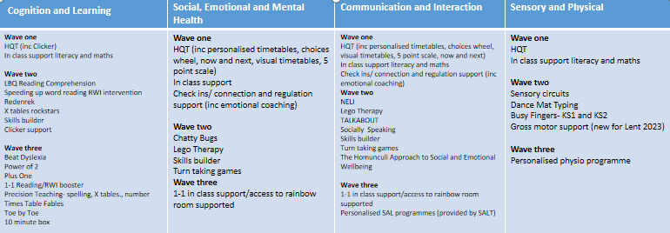

How does the school judge whether the support has had an impact?

Regular meetings (at least 3 times per year) are held where teachers and parents evaluate the PLP of a child with SEND. New targets are then set as a result of the meeting, if support needs to continue. If a child has not met any of their targets, the reasons for this will be discussed and then the target may be adapted into smaller steps, or a different approach may be tried to ensure the child makes progress. A copy of a child’s PLP will be given to parents.

Entry and exit tools are frequently used before and after a child receives extra support and intervention. The results of these tools are then used to measure the success of the extra help, and support class teachers in identifying any further gaps in knowledge or understanding.

As a school, each child’s assessment data is submitted to the Senior Leadership Team on a termly basis. This data is measured against national age related expectations. Class teachers continually assess each child and note areas where they are improving and where further support is needed. Children’s progress is tracked from their admission through to Year 6 and analysed by the Senior Leadership Team. Children who are not making expected progress are identified and, through termly Pupil Progress Meetings, a discussion is help about the difficulties these pupils are experiencing and what further support can be given to aid their progress.

Children may be removed from the Special Educational Needs register when they have made sufficient progress and no longer require additional help. You will be informed of this, via telephone call and/or in writing.

How can an Education, Health and Care needs assessment be requested (EHCAR)?

SEND support is adapted or replaced depending on how effective it has been in achieving the agreed outcomes. Where, despite the school having taken relevant and purposeful action to identify, assess and meet the SEND of the child, the child has not made expected progress, the school or parents should consider requesting an Education, Health and Care needs assessment. To inform its decision, the Local Authority will expect to see evidence of the action taken by the school as part of SEND support.

Who can I contact for further information or to discuss a concern?

The first point of contact is your child’s class teacher to share your concerns. You could also arrange to meet with the SENCo, Miss Egerton. The school’s SEND Policy, which is on the school’s website, should also be read in conjunction with this SEND Information Report.

What if I have a complaint about the SEND Provision for my child?

In the first instance, any concerns should be raised with your child’s class teacher and/or the SENCo. If your concern has not been resolved, please refer to and use the schools’ Complaints Procedure, which can be found on the school’s website.

Please see the following policies on our website for further information:

• SEND policy
• Safeguarding policy
• Connection and regulation policy
• Complaints procedure
• Supporting pupils with medical conditions
• Equality policy

Reviewed: March 2023
Review date: March 2024

